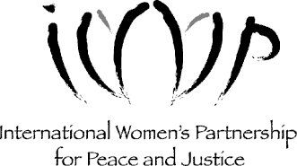

                - If you are interested to attend the BEST course, please fill out the following application and return it to IWP before July 1, 2018.

Please send by email if possible: ginger@womenforpeaceandjustice.org or by mail: PO Box 3, Mae Rim, Chiang Mai 50180 Thailand

Name:

Nationality or ethnicity:

Age:

Contact Information (the easiest way for us to contact you: email, phone, mail, etc):

Organization contact information (if applicable):

How did you find out about this course?

What is your current work/study (area of focus)?

What are your expectations from this course?

How do you foresee the BEST course will support your work/study/lifestyle now and your vision for the future?

Do you currently have a spiritual practice? If so, please describe.

What links do you see between spiritual practice and your activism/social change work?

What are 3 personal strengths you have that you will contribute to this course and community?

What are 3 skills/areas that you would like to develop in this course and community?

Anything else you’d like us to know about you?

